The Survey

Name: __________________________________

How are you feeling? (Circle One)

Tell us who YOU are

What is the most interesting thing you experienced in life?

What do you want to accomplish in your life?
(Try thinking in terms of relationships, career, desires/dreams, etc.)

- What are your current pursuits?

- What do you want to accomplish in 5 years?

- What do you want to accomplish in 10 years?

- What do you want to have accomplished by the time you are 60 years old?

How do you relieve (deal with) your stress?

What do you miss doing that you used to do in the past? (back in HS, in Korea, etc)

How has God been involved in your day-to-day life?

What are you most grateful for?

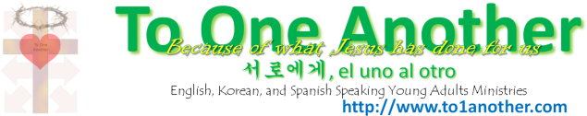
Things YOU’d like to learn or others to learn through our ministry

- In our young-adult group, I would like to discuss and study these topics:

Because I personally want to learn about them | Because these topics would benefit many young adults (my peers)
 |  | Money
 |  | Dating
 |  | Marriage
 |  | Basic Christianity
 |  | Fruit of the Spirit
 |  | Other Religions
 |  | Eternal Life
 |  | Friendship with Jesus
 |  | Careers
 |  | History of Christianity
 |  | Our Ministry
 |  | Joy
 |  | Peace
 |  | Love
 |  | Contentment
 |  | My Identity in Christ
 |  | Acts of Mercy
 |  | Serving Others
 |  | School
Because I personally want to learn about them | Because these topics would benefit many young adults (my peers)
 |  | Parents/Family
 |  | Sin (and avoiding it)
 |  | Lifestyle of Faith/Trust
 |  | Guilt
 |  | Spiritual Gifts
 |  | How to defend your faith
 |  | How to share your faith
 |  | How to pray
 |  | How to study the Bible
 |  | Friendships
 |  | Stress
 |  | Depression/Loneliness
 |  | Quiet Time
 |  | Balanced Lifestyle
 |  | Other:
 |  | Other:
 |  | Other:
 |  | Other:
How do YOU want to be involved in our young-adults ministry?

- Help set up weekly meetings
- In fields of music
- In fields of video/productions
- Praying behind the scenes
- Picking up needed supplies and materials
- Making phone calls and sending emails
- Welcoming others
- Providing rides
- Advertising
- _____________________________
_____________________________
_____________________________
- Any of the above

- Here are some questions I have about God or being a
Christian:

- Here are some ways our ministry can help our peers:

